EBS, CREATING VOLUME
BY: SETIKA MUNJAL, 2301410029
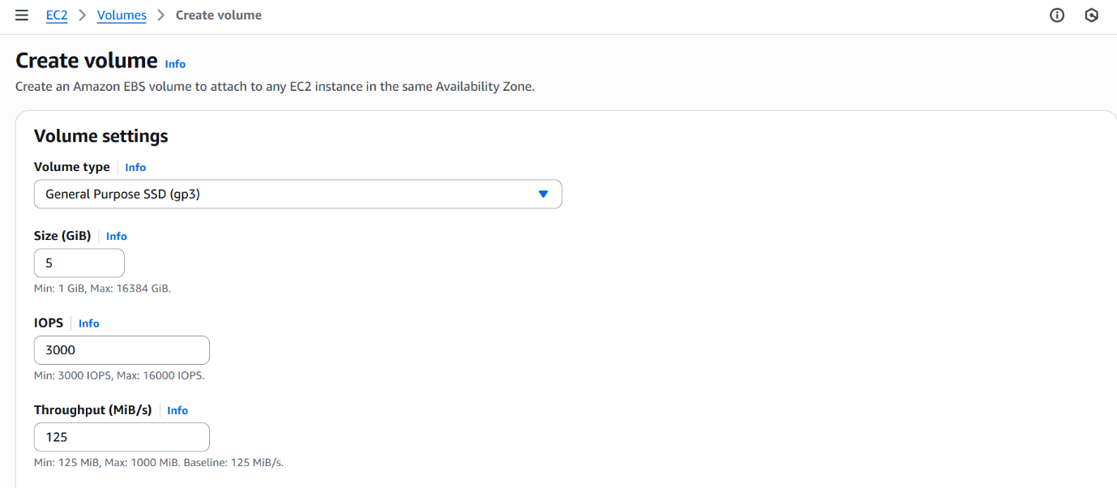
Search EC2 and scroll to volumes.
Click on create volume and choose the settings as per the requirements. (here we have chosen gp3 -> size=5 and rest are default.
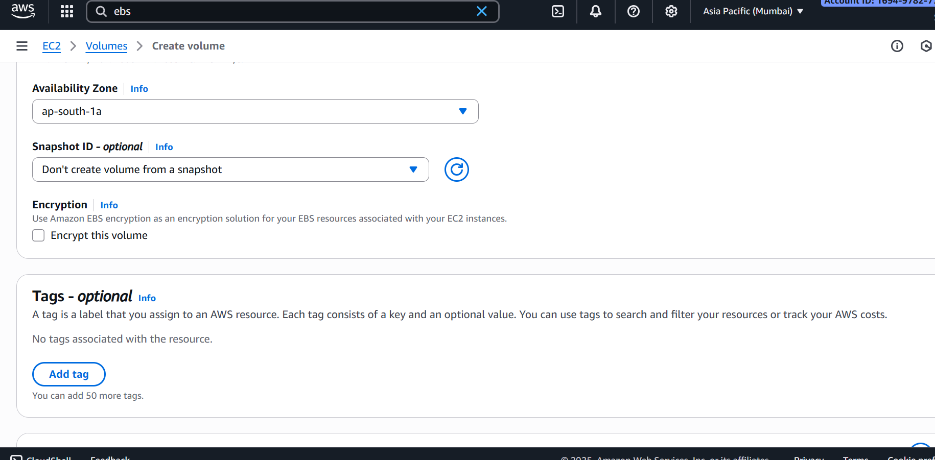
Keep the availability zone as the required zone in other activities too.
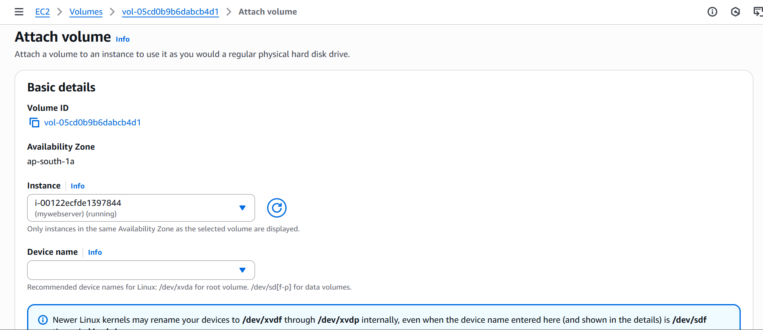
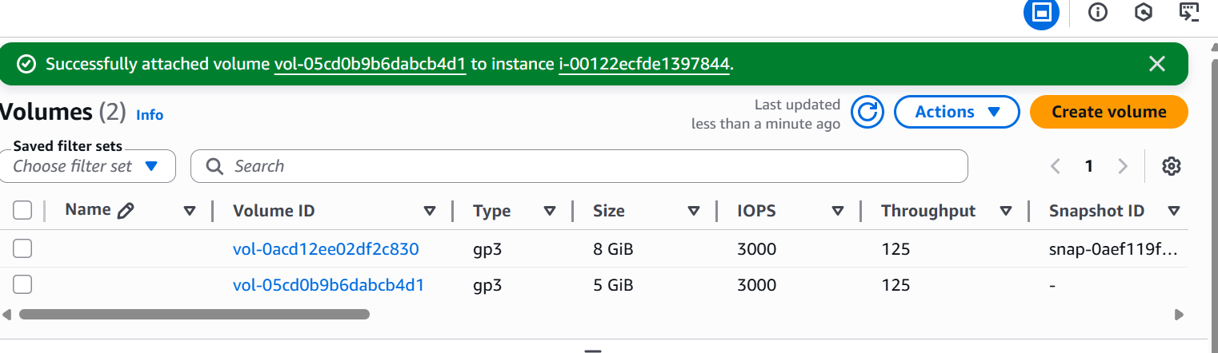
Newly created volume is marked by the red colour.

